**ShopNest Store**

**Introduction**

In Portugal's e-commerce platforms, ShopNest is the top department store. Providing a single point of contact streamlines the procedure and acts as a smooth link for small enterprises in different parts of Portugal. These retailers can display and sell their goods through the ShopNest Store, and ShopNest logistics partners make it easier for them to ship directly to customers. Authentic commercial information that has been anonymised is represented.

**Detailed Report Regarding the Findings**

**1. Top Categories by Total Price:**

• Identify and visually represent the top 10 product categories by total sales.

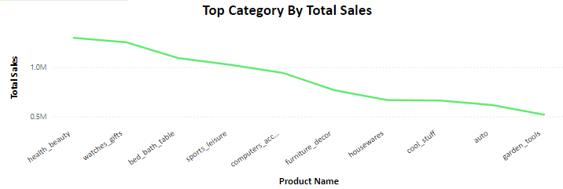

**Observation:**

* From the line chart we have extracted the top 10 items according to the total sales. Health beauty category products have the highest number of sales which is 1.2 million and garden tools products have 10 the highest number of sales which is 518k.

**2. Delayed Orders Analysis:**

• Determine the number of delayed orders in each category. An order is considered delayed if the actual delivery date is later than the estimated delivery date.

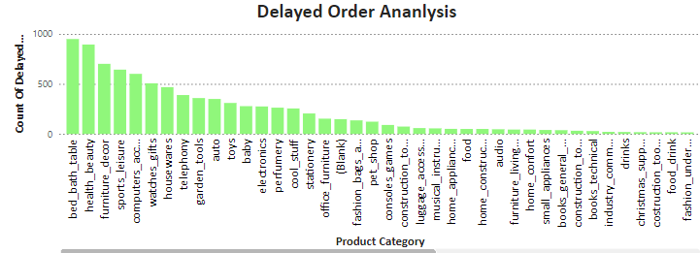

**Observation:**

* From the Bar chart we can conclude that the bed bath table has the highest number of delayed orders which accumulated to 949 delayed products. And least number of delayed orders in the product category is the flower which is 1

**3. Monthly Comparison of Delayed and On-Time Orders:**

• Create a dynamic visual that compares the number of delayed orders to the number of orders received earlier for each month. Utilize the drill through the cross-report feature to provide a detailed analysis of late and on-time deliveries.

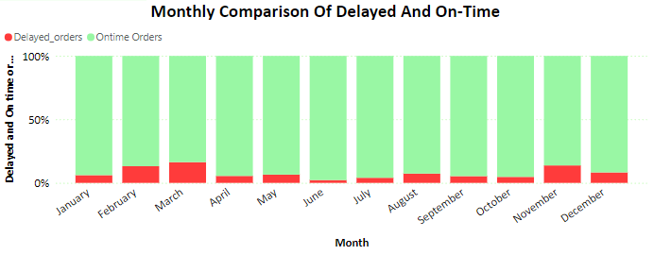

**Observation:**

* From the stacked column chart, we can conclude that in May, Orders were delivered on time to the customer which has the highest number of on-time orders (11559). March is the Most Delayed delivery which is (1865)
* When we look at the success rate in June the on-time delivery has a success rate which is 97.76% and the least delayed delivery which is 2.24%. So, in conclusion, June was a successful month.

**4. Payment Method Analysis:**

• Analyze the most frequently used payment methods by customers using a visually appealing representation, such as a pie chart or other suitable visuals.

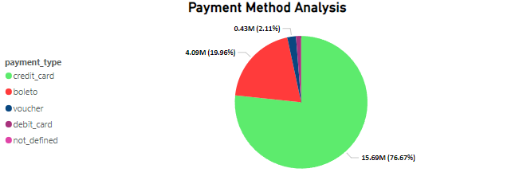

**Observation:**

* From the pie chart we can conclude that the most used payment is a credit card which has a total payment value of 15.69 million. The least used are debit cards which have a payment value of 256K.

**5. Product Rating Analysis:**

• Determine the top 10 highest-rated products and the bottom 10 lowest-rated products using a bar or column chart.

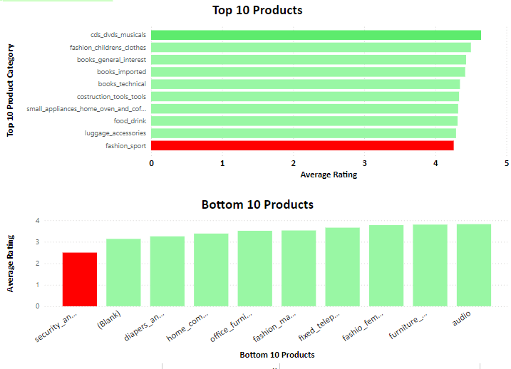

**Observation:**

* We can conclude from the top 10 products that the most rated products are cds-dvds-musical which have an average rating of 4.64.
* We can conclude from the bottom 10 products that the least-rated product is security and services which have an average rating of 2.50.

**6. State-wise Sales Analysis:**

• Identify and visually represent states with high and low sales, providing a clear understanding of regional sales performance.

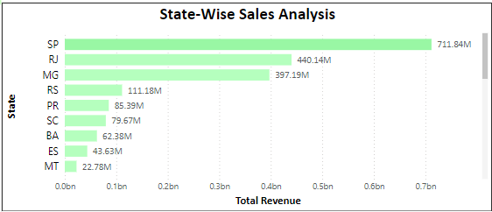

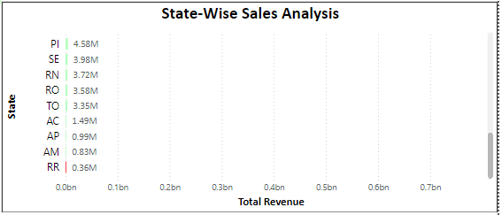

**Observation:**

* From the state-wise sales analysis, we can conclude that the state which has the greatest number of sales is SP which is 711.84 million.
* The state which has the least number of sales is RR which is 0.36 million.

**7. Seasonal Sales Patterns:**

• Investigate and visualize any seasonal patterns (Quarterly) or trends in sales data for the year.

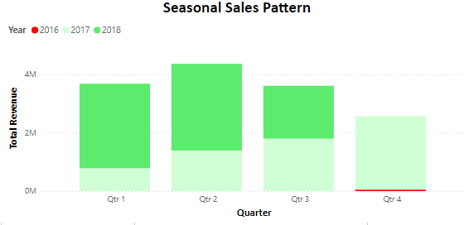

**Observation:**

* The highest revenue collected in the second QTR in the year 2018, which has a total revenue of 2.9 million.
* The least revenue collected was in the fourth QTR in the year 2016, which has a total revenue of 50K.

**8. Revenue Analysis:**

• Determine the total revenue generated by ShopNest Store and analyse how it changes over time (Yearly). Represent this information through suitable visuals to highlight trends and patterns.

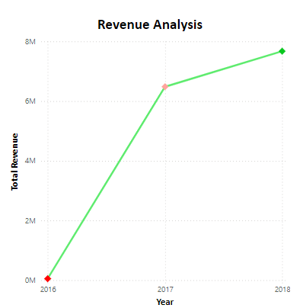

**Observation:**

* There has steady increase in revenue when we compare each year. 2016 has the lowest revenue and 2018 has the highest revenue. There is a huge difference when 2016 and 2017 are compared. In 2016 the total revenue was 55K and in 2017 is 6.4 million. The total revenue in the year 2018 is 7.6 million.

**Data Model**

